\

#### Women’s Workshop

Caption goes here

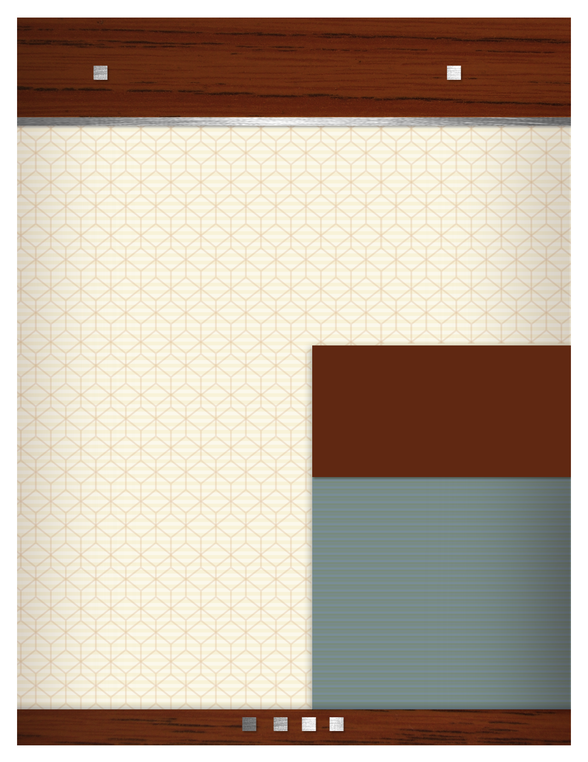

“Sex, Love, and Longing”

* Intimacy
* Relationships
* Love Addiction /Avoidance

CREATE A LIST OF WHAT YOU DO OR   
HERE.

• List es or products here.

• List your services or products here.

• List your services or products here.

• List your services or products here.

• List your services or products here.

• List your services or products here.

• List your services or products here.

• List your services or products here.

Come Join Us!

Come join us for this 6-week workshop. The group will focus on women’s issues concerning intimacy, love addiction and avoidance.

The format of the group will include psycho-educational and therapeutic process.

A full 6-week commitment is required for attendance.

Contact Debra for information

**When: August 25th 5:00-6:30 (Thurs)**

**Where: The office of Debra L. Kaplan**

**Price: $350.**

(The cost of the workshop will include workbooks and materials.)

**Phone:** **520.203.1943**

**Fax: 520.731.1764**

**6151 E. Grant Road  
Tucson, Arizona 85712**

[www.debrakaplancounseling.com](http://www.debrakaplancounseling.com)

[info@debrakaplancounseling.com](mailto:info@debrakaplancounseling.com)

Debra L. Kaplan

MA, LAC, LISAC, CMAT, CSAT-S

Caption goes here

#### Debra L. Kaplan, MA, LAC, LISAC, CMAT, CSAT-S